**IOT LAB**

**Program Title – Temperature Sensor Program.**

**Aim – Demonstrate the working of Temperature Sensor.**

**Hardware Required-**

* Arduino Board
* Breadboard
* Temp sensor
* Wires

**Circuit Diagram –**

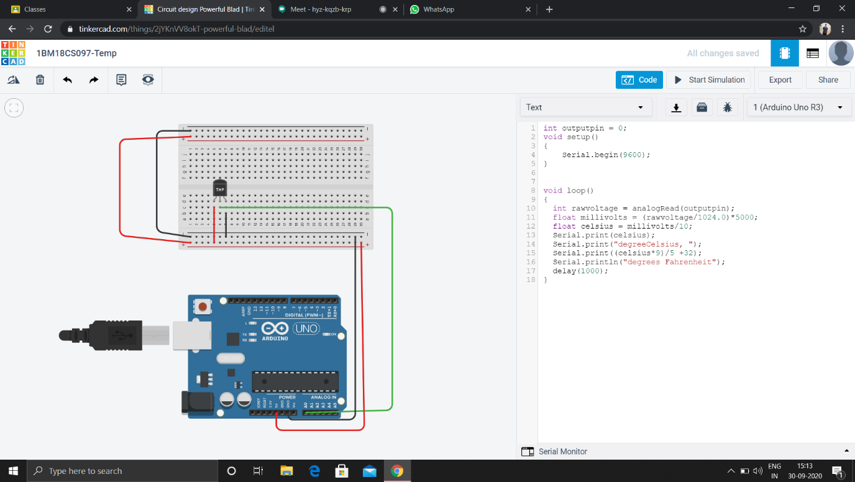

**Code -**

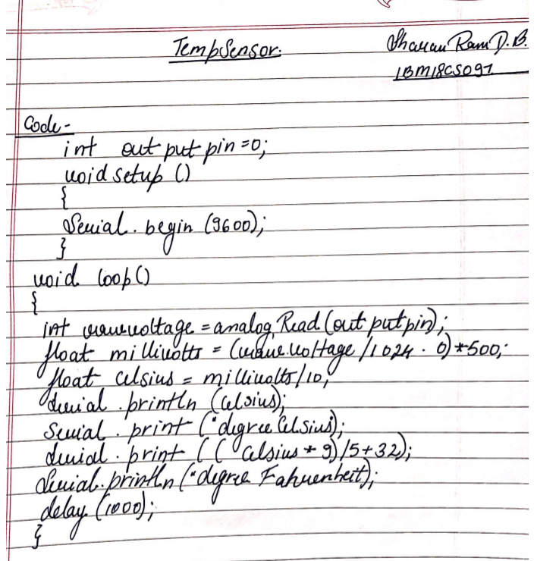

**Observation /Output –**

**The temperature is sensed whenever the variations occur in the heat sensor and also the temperature is converted into Fahrenheit.**